**Software Project Plan**

for

**IKIGAI 2.O**

# 

# 

Prepared by Salman Khan, Maryum Tanvir, Mavra Mehak

FAST - National University of Computer & Emerging Sciences

April 29th,2025

# Work Breakdown Structure

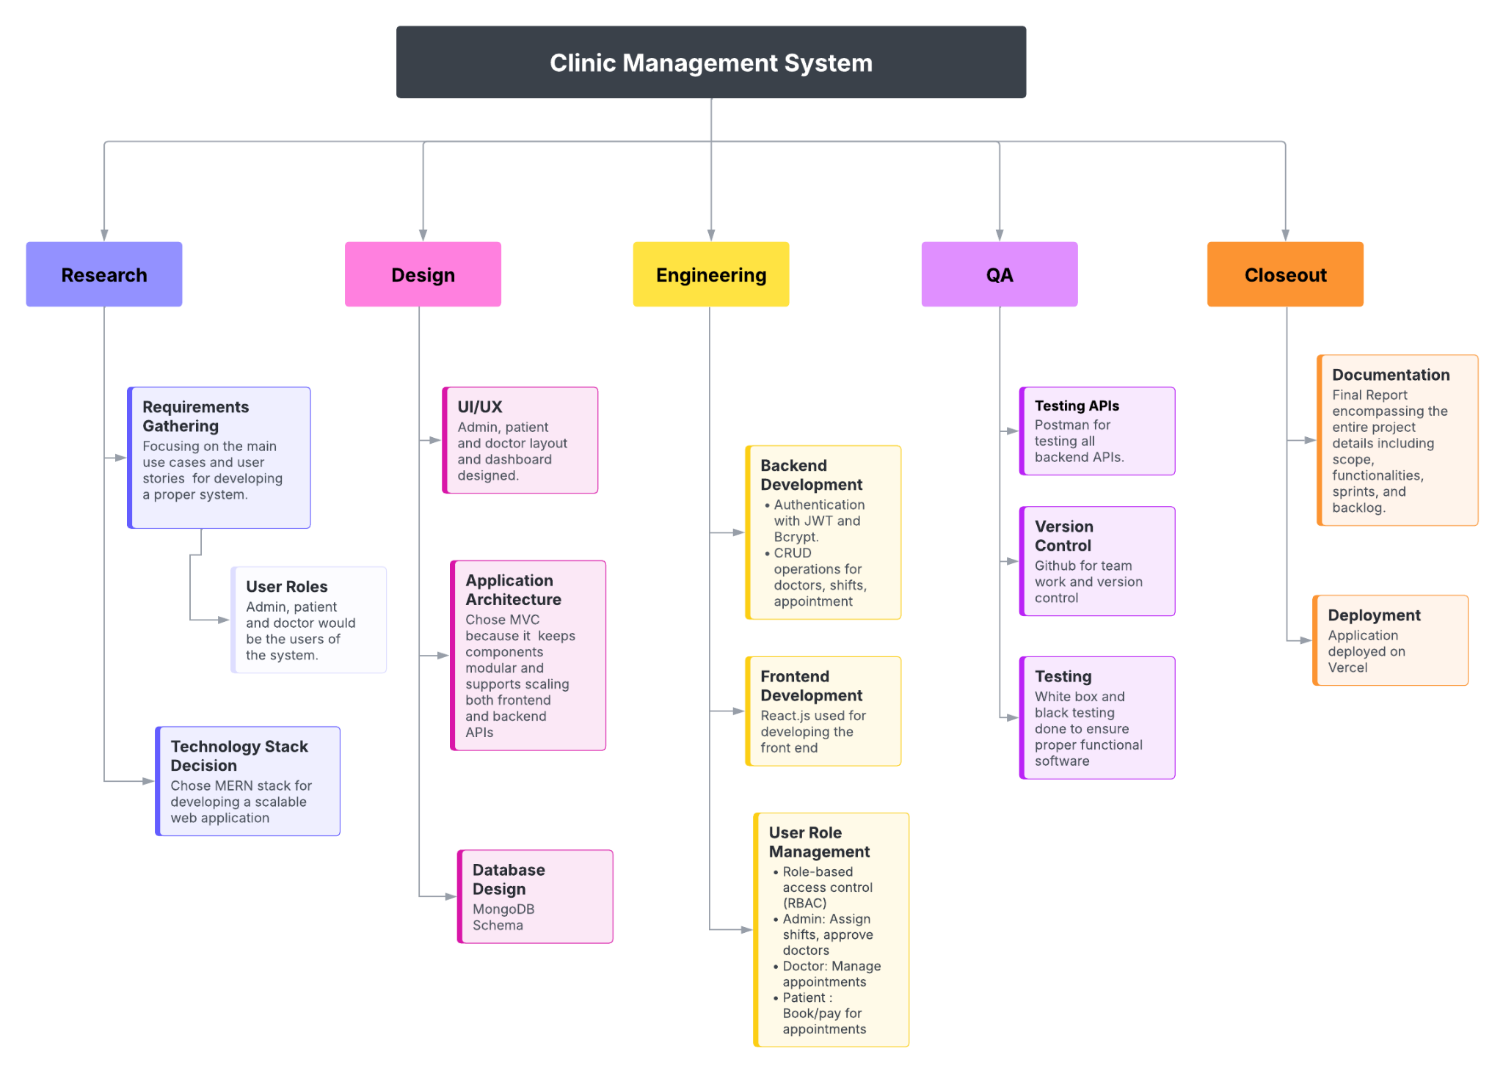

# Gantt Chart

